CRM Application for Jewel Management

## 

## College Name: Kumaraguru College of Liberal Arts and Science

## College Code: BRUAX

## TEAM ID : NM2025TMID25597

## TEAM SIZE : 4

## Team Leader : M ATHI SESHAN

## Email: athiseshan.23bds@kclas.ac.in

## Team Member 1 : ANAMIKA M

## Email: anamika.23bds@kclas.ac.in

## Team Member 2 : LATIKA SAKTHIVEL

## Email: latika.23bds@kclas.ac.in

## Team Member 3 : VAISHIGA R

## Email: vaishigarajkumar21@gmail.com

**INTRODUCTION**

The Jewel Inventory System is a comprehensive and integrated software solution specifically designed to streamline, automate, and efficiently manage the inventory and sales processes of jewellery stores and jewellery manufacturing businesses. Managing jewellery items can often be complex due to the wide variety of products, including gold, silver, diamonds, gemstones, and customized designs, each with different weights, purity levels, and pricing structures. This system aims to address these challenges by providing a centralized, efficient, and user-friendly platform for tracking and controlling jewellery inventory in real time.



**OBJECTIVES**

1. **Enhance Customer Relationship Management**  
   Build stronger, long-term relationships with customers by maintaining detailed customer profiles, tracking purchase history, and recording all interactions. This helps in understanding customer preferences and delivering personalized services.
2. **Streamline Sales and Order Management**  
   Optimize the entire sales process, from initial customer inquiry to final order fulfillment, ensuring faster response times, reduced errors, and improved overall accuracy in sales operations.
3. **Improve Inventory and Product Management**  
   Maintain a well-organized, real-time record of jewellery inventory, including product details, weights, categories, and pricing. This ensures efficient stock handling, prevents overstocking or shortages, and improves overall inventory control.
4. **Enable Targeted Marketing and Campaign Management**  
   Use customer data to plan and execute targeted marketing campaigns, thereby increasing customer engagement, driving repeat purchases, and boosting overall sales through data-driven decision-making.
5. **Boost Operational Efficiency**  
   Minimize manual work and reduce errors by automating routine tasks, integrating different business processes, and ensuring smooth coordination between departments.
6. **Provide Business Insights and Analytics**  
   Leverage sales and inventory data to generate insightful reports, identify business trends, and support strategic decision-making for growth and profitability.
7. **Support Omnichannel Customer Experience**  
   Deliver a seamless and consistent shopping experience across multiple sales channels — whether in-store, online, or through third-party platforms — ensuring customer satisfaction and loyalty.
8. **Ensure Data Security and Compliance**  
   Safeguard sensitive customer and business information by implementing robust security measures and complying with industry regulations, ensuring trust and legal adherence.

**Creating Developer Account: By using this URL -** [**https://developer.salesforce.com/signup**](https://developer.salesforce.com/signup)

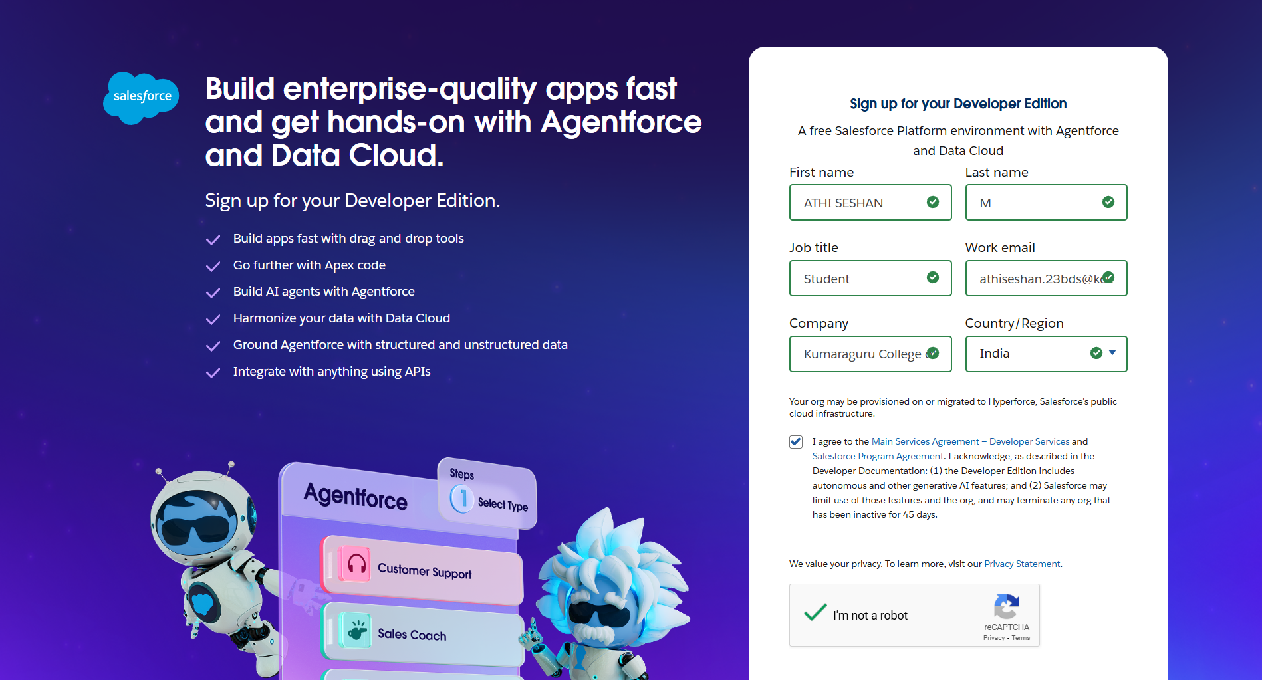

**Create Jewel Customer Object :**

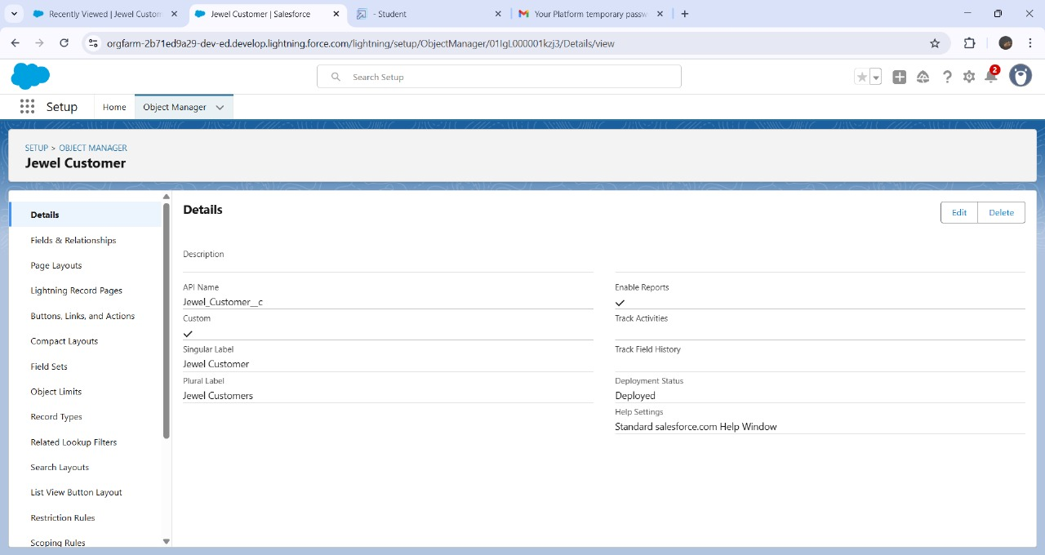

**Create Objects - Item , Customer Order , Price , Billing :**

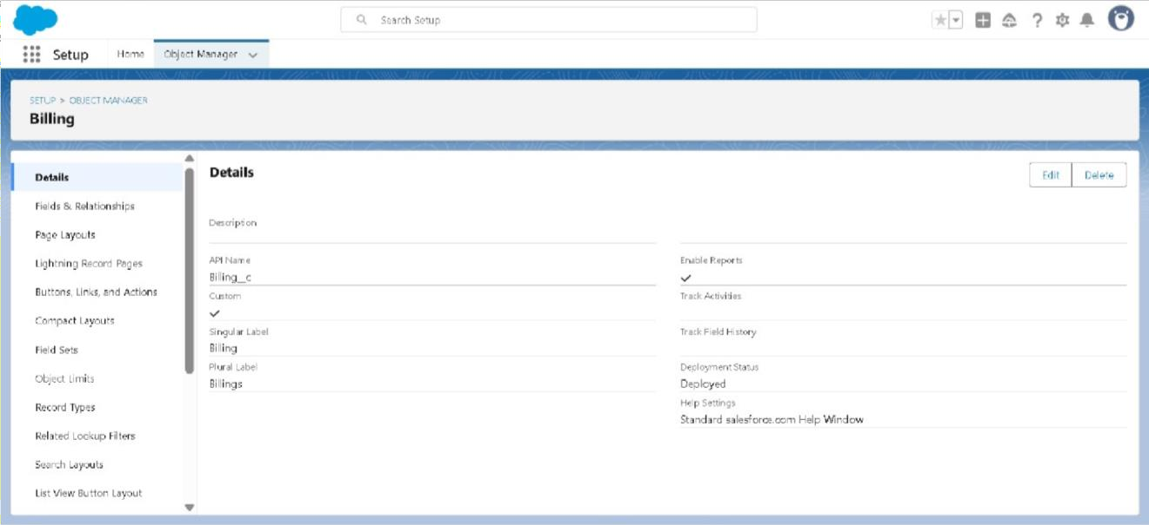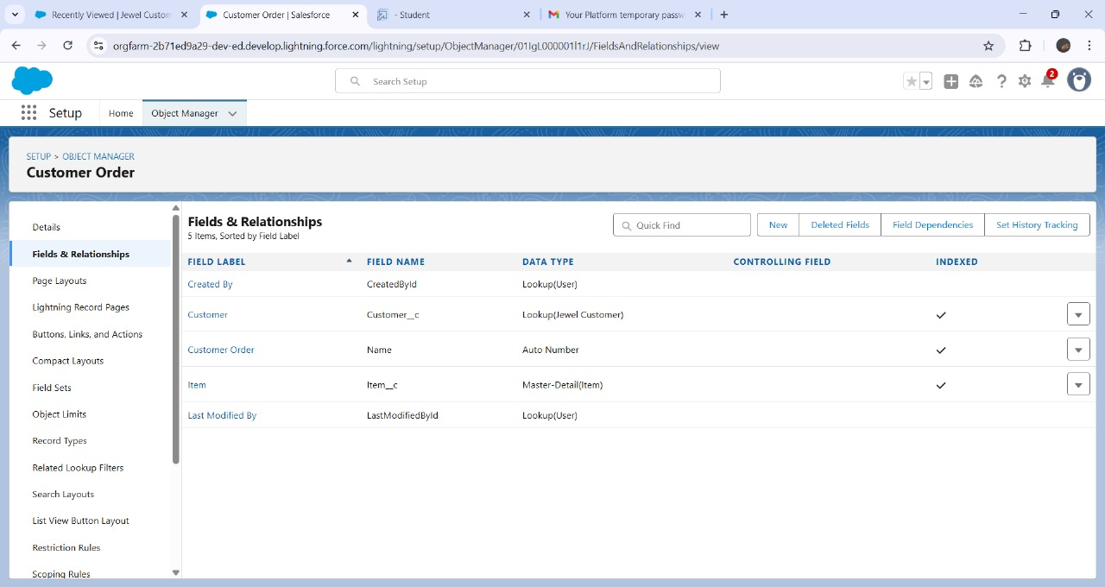

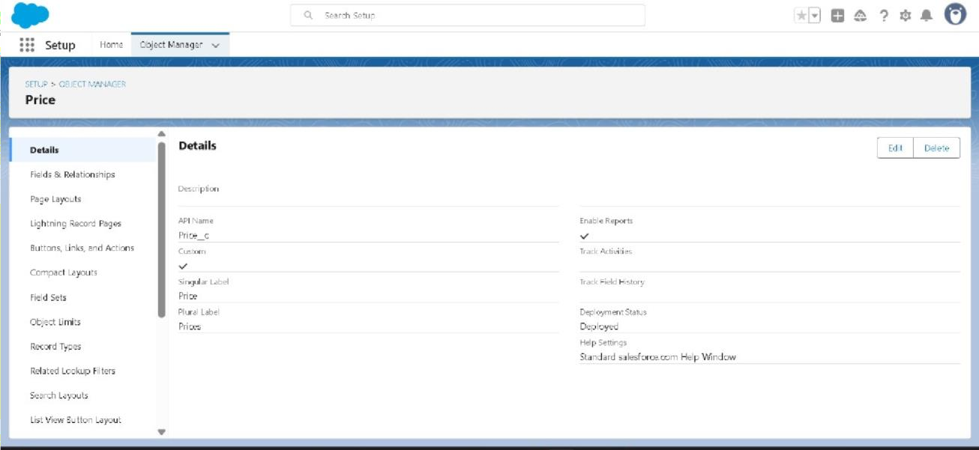

To Create A Tab-Item, CustomerOrder, Price , BillingObjects:

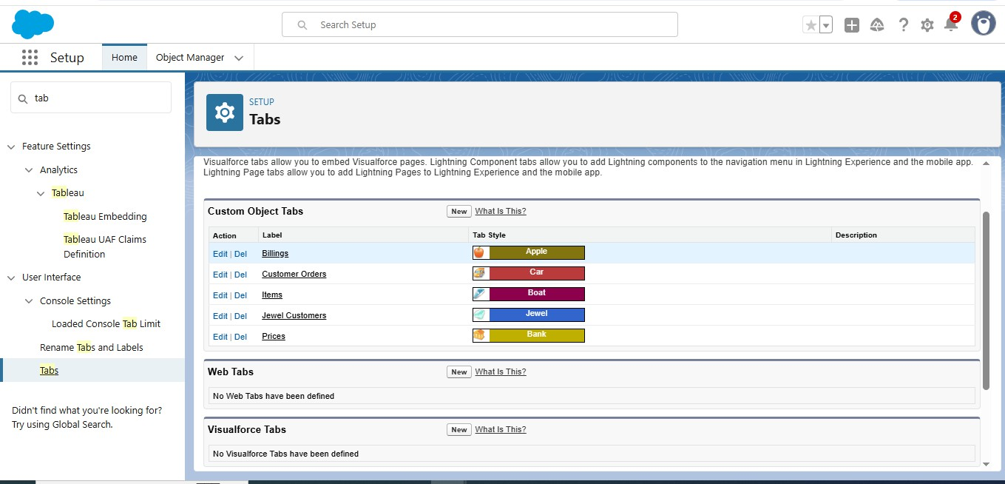

Create a LightningApp-Jewellery Inventory System:

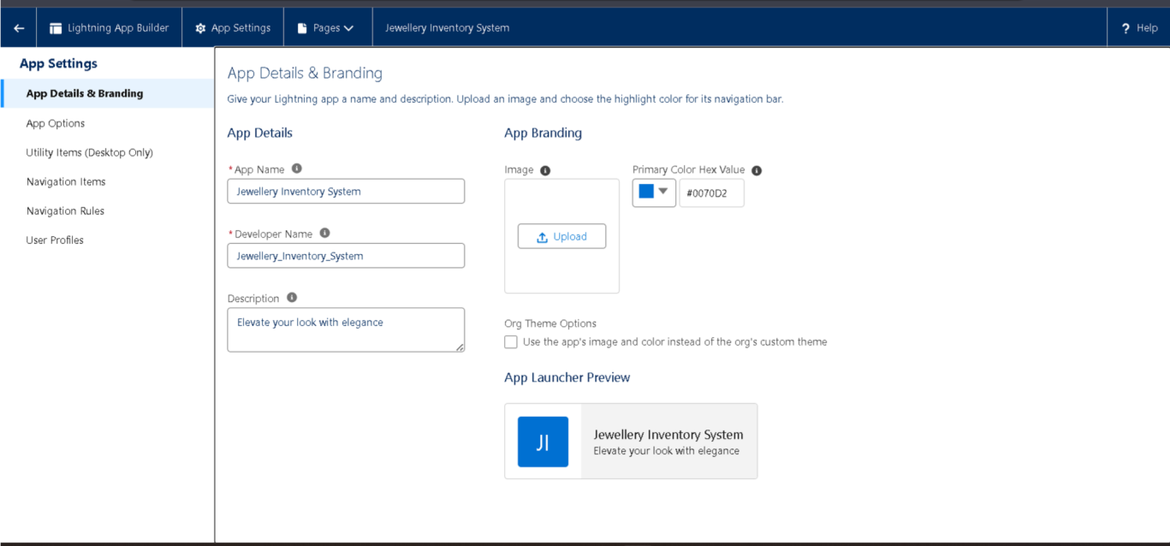

Creating Lookup Relationship-Customer:

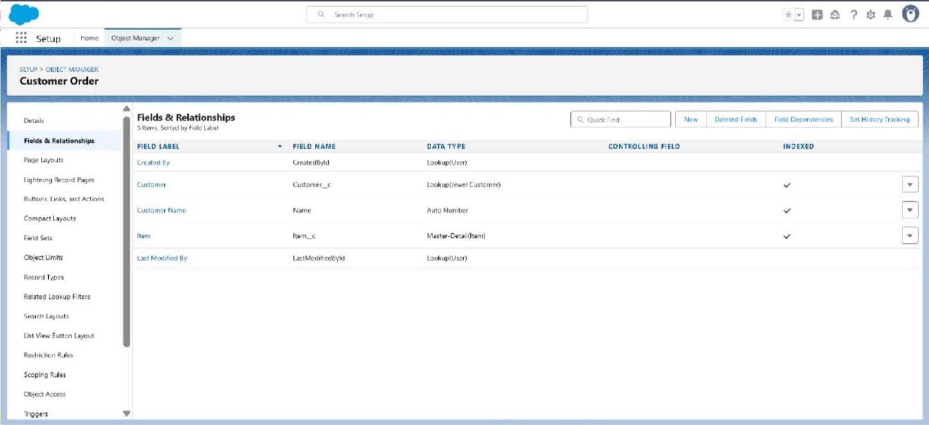

Creating a Master-Detail Relationship-Item:

Creating Text Field, Phone, Email in Jewel Customer Object:

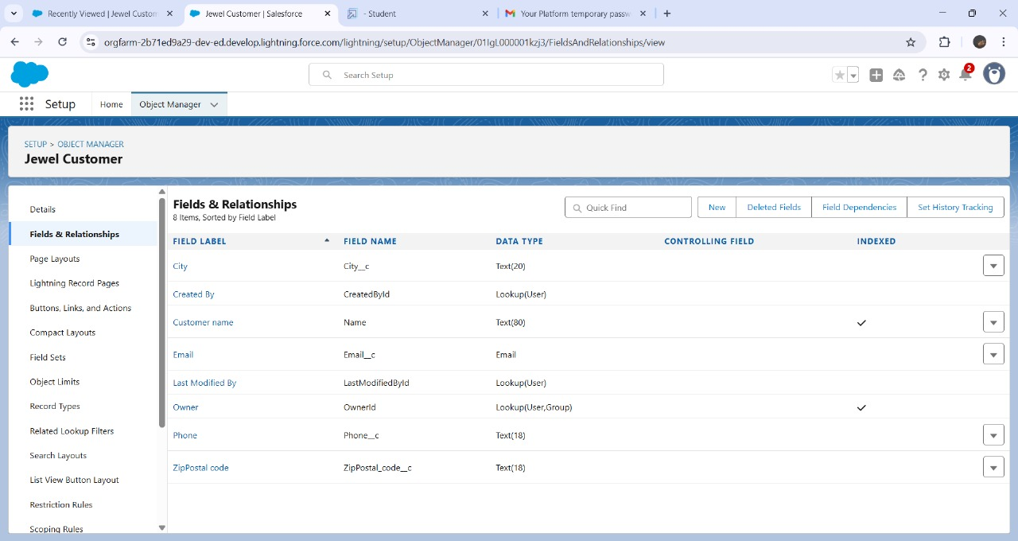



Creating the number, Picklist fields in Item object:

Creating Formula Field (Cross Object) in Item Object:

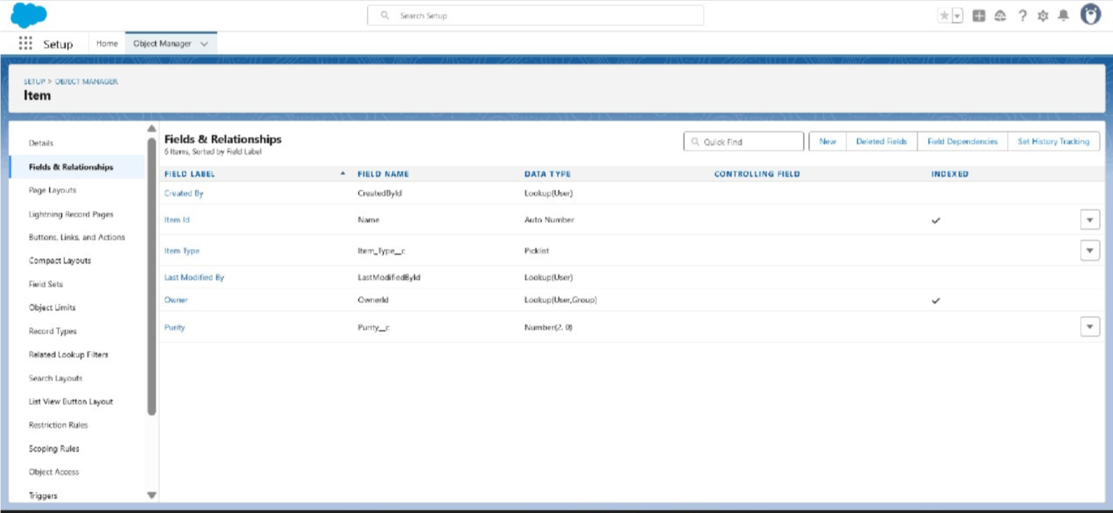

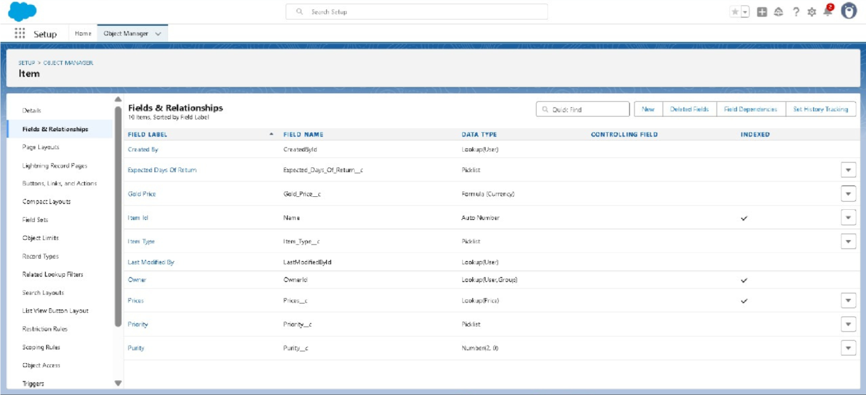

Creating the validation rule-Postal Code & Validation Rule For Jewel Customer Object: Creating the validation rule – Validation Rule for Item:

Gold Smith Profile:

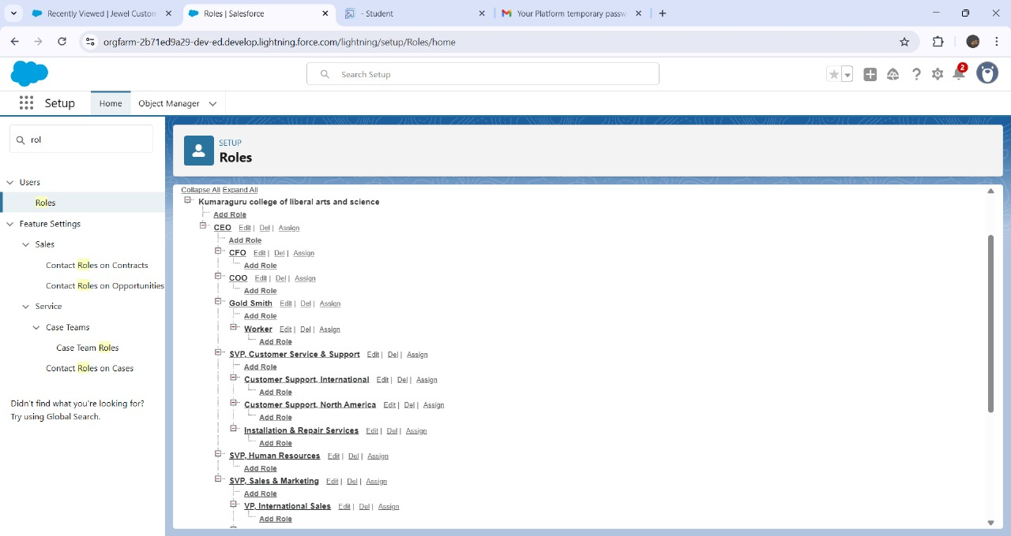Creating Gold Smith Role:

Create User:

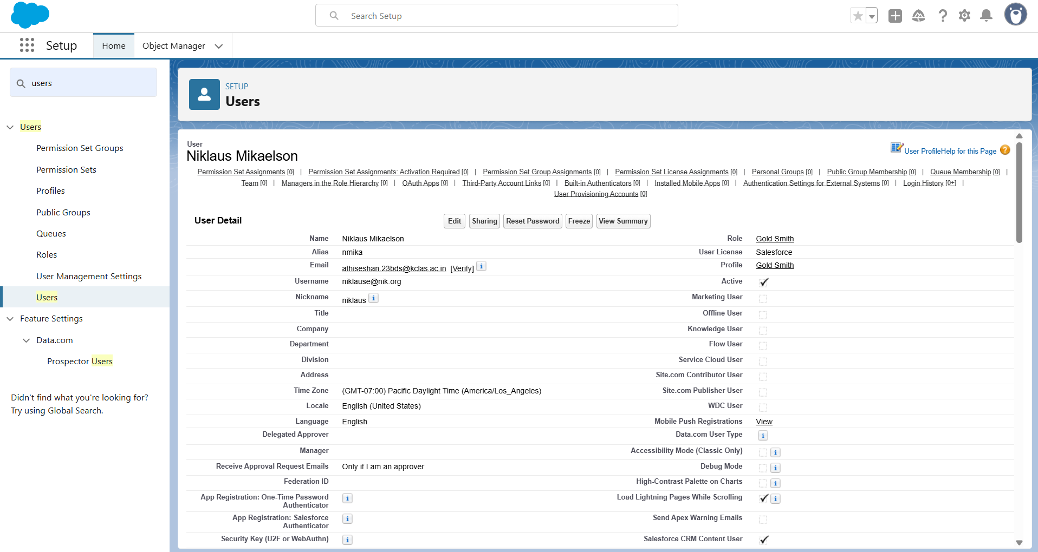

To Create Gold & Silver Page layouts:

To create a Record Type-Gold&Silver:

Creating permission set:

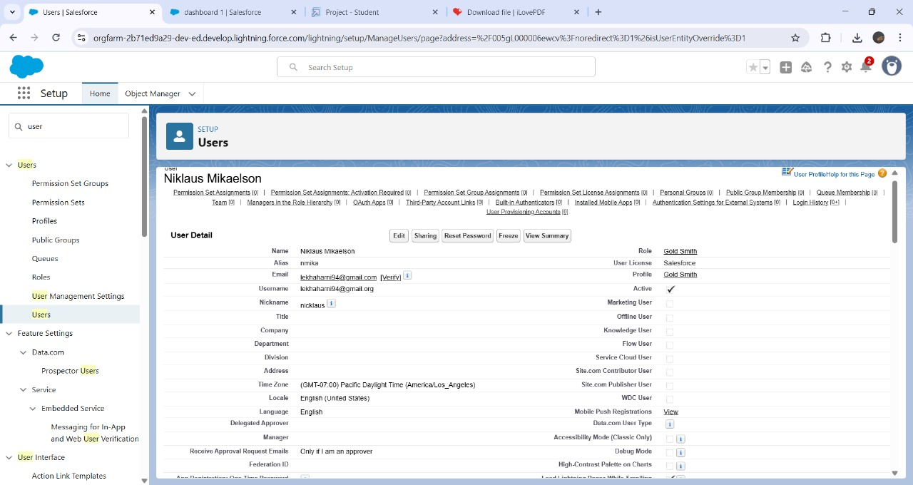

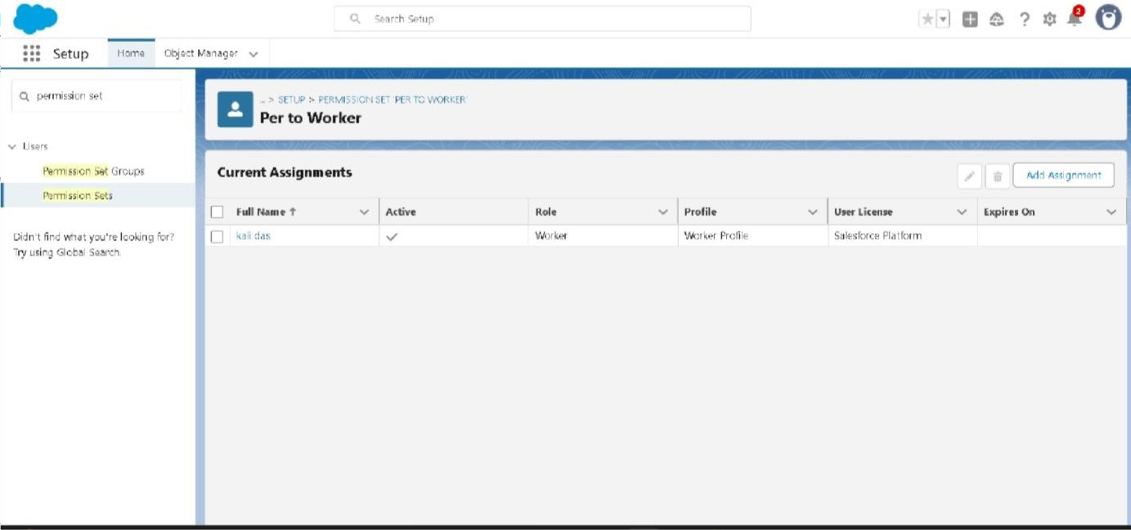

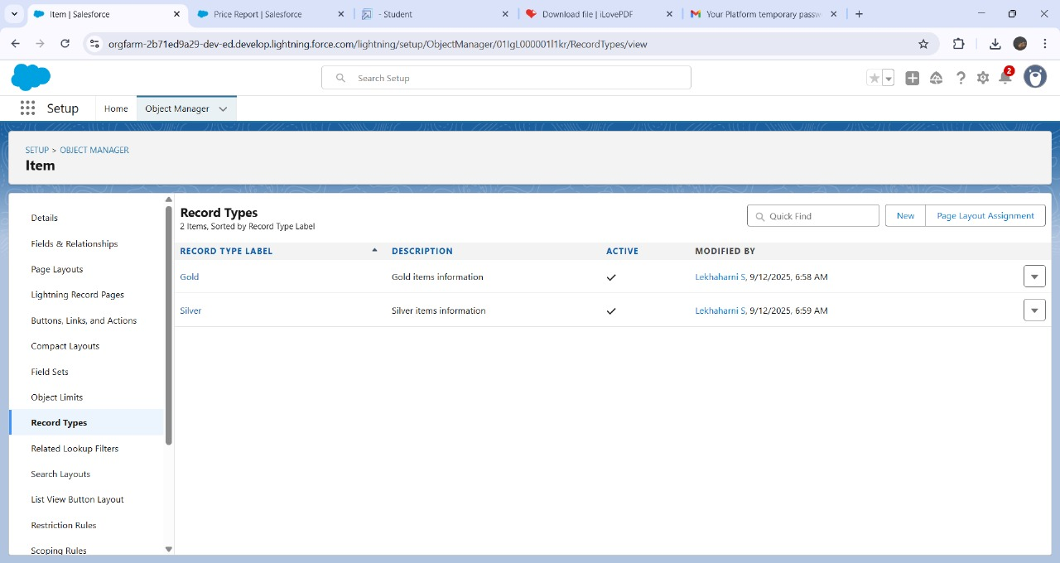

Create a Trigger Handlerclass & TheTrigger:

Create, View and Delete a Record (JewelCustomer):

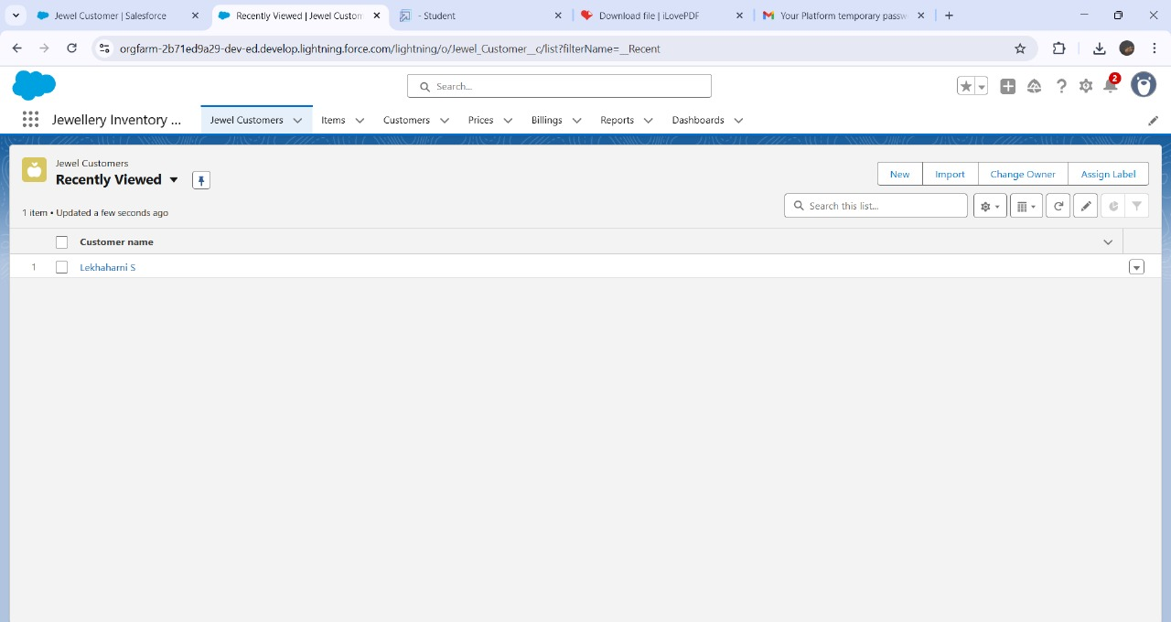

CreateReport:

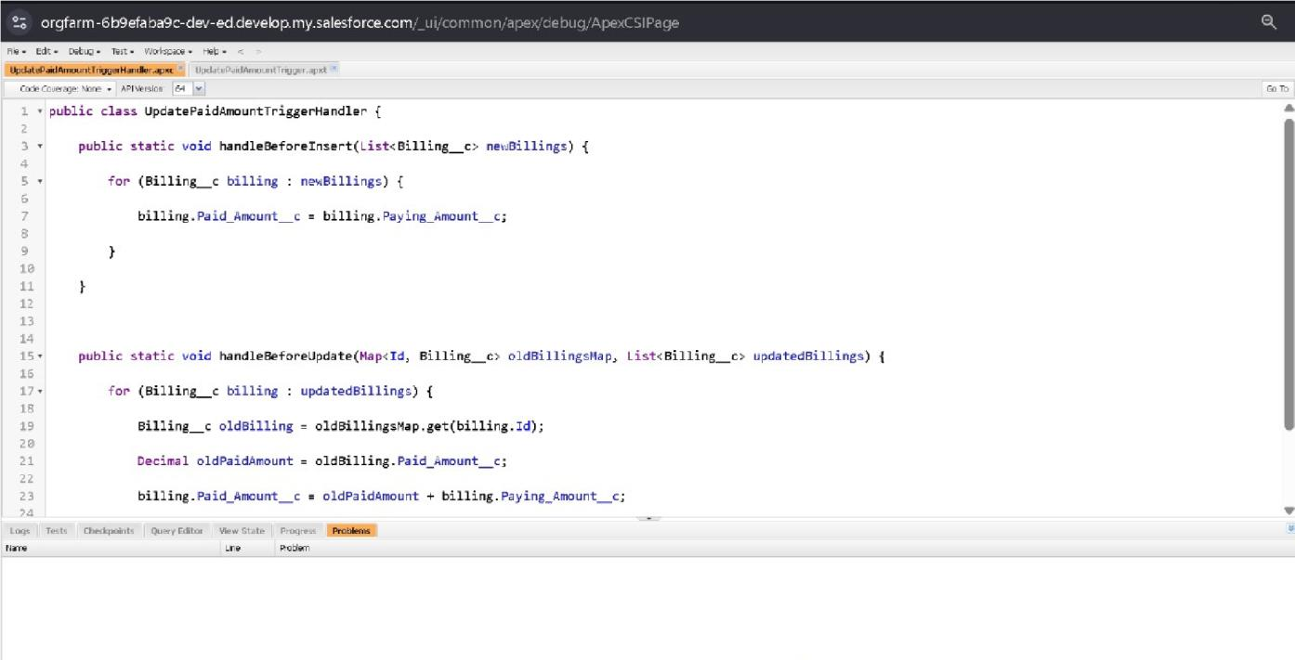

Create Dashboard:

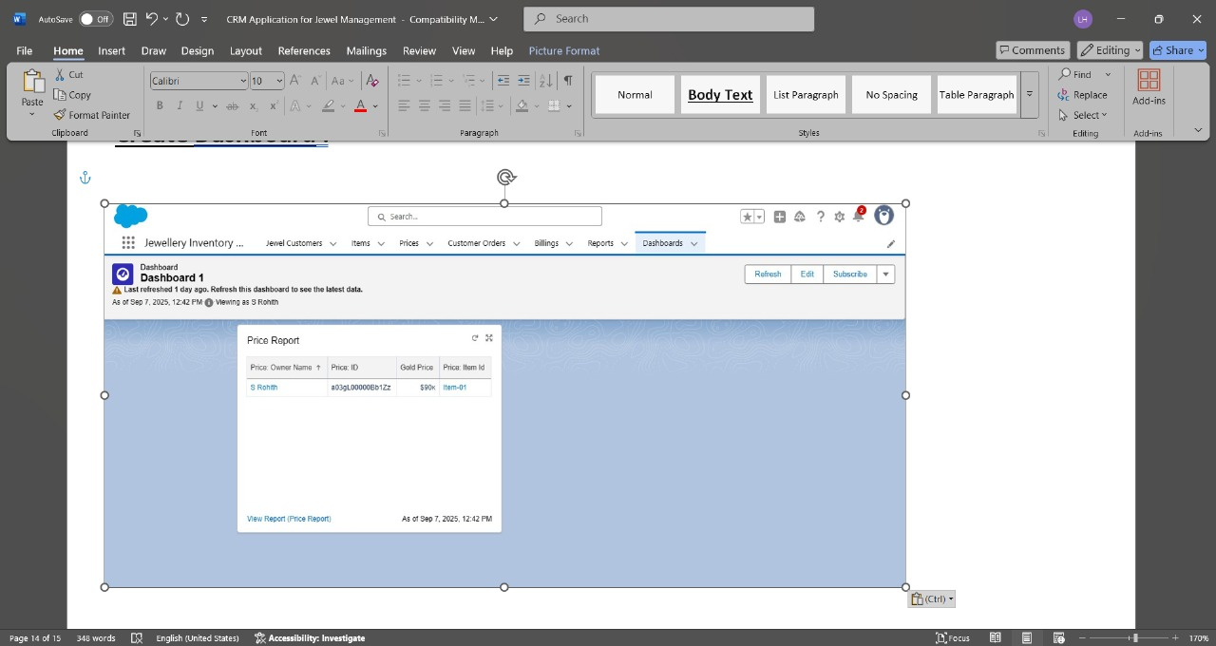

Create A Flow:

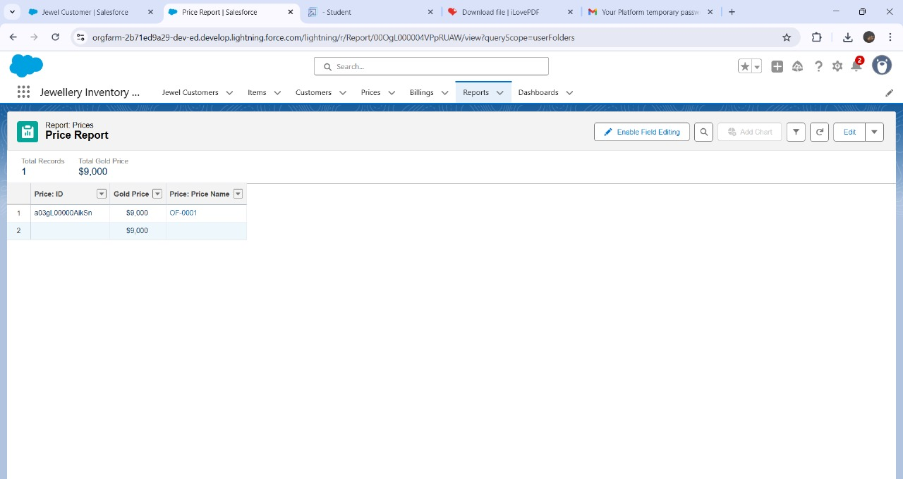

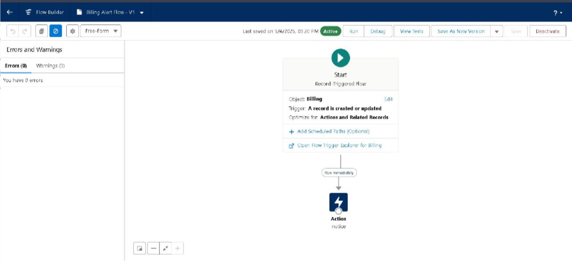

**CONCLUSION**

The CRM Application for Jewel Management has successfully achieved its goal of streamlining customer interactions, sales tracking, and inventory management for jewellery businesses. By integrating these critical operations into a single platform, the system has significantly enhanced the efficiency of day-to-day processes and reduced manual effort. As a developer, the primary focus was on designing and developing a secure, scalable, and user-friendly solution that meets the specific needs of the jewellery industry while maintaining accuracy and reliability.

The implementation of this system has resulted in improved operational efficiency, faster decision-making, and enhanced customer engagement through better relationship management. Additionally, the project has laid a strong foundation for future enhancements, including advanced analytics, reporting features, and mobile application support, which would further improve accessibility and business intelligence.

Overall, this project demonstrates how technology can transform traditional business processes, enabling jewellery businesses to operate more effectively, stay competitive in the market, and deliver superior value to their customers.